*ProtoControl*

System Architecture Diagrams

Team Members:

[Kelly Mae Allen](mailto:kmallen5@ncsu.edu)

[Nida Kosedagi](mailto:nkoseda@ncsu.edu)

[William Wood](mailto:whwood@ncsu.edu)

[Parker Sexton](mailto:pbsexton@ncsu.edu)

[Abisha Fenn](mailto:arfenn@ncsu.edu)

Sponsoring Entity:

Parker Sexton

Date: 9/19/23

# 

# ***Technical Writing & Structure rules (5 points):***

*This includes quality of writing, clarity of explanations & information presented, and document formatting Proper Grammar\Spelling. Follow the formatting rules below:*

1. *DO NOT include the instructions from this template, grading points, or structure rules in your document. They are only to help you understand the structure of the document.*
2. *Once you are done, refresh the table of contents to reflect yours.*
3. *Please upload this as a team on your project website at the bottom.*
4. *The submitted document should be a* ***Google Doc*** *(Neither MS Word nor PDF) (Link is ok.)*
5. *The filename should be* ***System_arch_diagrams_PrjNum_ProjName_SemYear***
6. *Include page number*
7. *Include captions and a brief explanation for each drawing, figure, and chart*
8. *Include sections and subsections as needed and appropriate*
9. *Instead of a long paragraph, use illustrated bullet points and tables whenever relevant and possible. (Proper organization of the information is more important than simply writing long textual paragraphs)*

Table of Contents

**Technical Writing & Structure rules (5 points): 1**

**1. Project Background (5 points): 3**

Key Product Requirements: 3

Key features: 3

Key constraints: 3

**2. Product Concept Diagrams/Drawings (25 points): 4**

2.1a ProtoPad 4

2.1b ProtoPad Key (zoomed in) 5

2.2 ProtoKit 6

2.3 Modular (location dependent) 7

2.4 Modular (component dependent) 8

2.5a Mobile Device as Touch Screen 10

2.5b Mobile Device as Touch Screen (zoomed in) 11

2.6 Software UI 11

Concept differences table and mockup demo preparation: 12

**3. User operational Flowcharts/process diagrams (20 points) 13**

**4. System Functional Block Diagram (25 points) 14**

**5. Table of Trade-offs (10 points) 17**

**6. Design challenges 18**

**7. First technical milestone Preparation (“Hello World” demos) 19**

**8. Long-lead-time or critical items for purchasing 20**

# **Project Background *(5 points)*:**

*This section talks about the short project objective (1 / 2 sentence) and the background. One paragraph summarizing project background, problem statement, and motivation/benefit to a customer for the product you will design This section* ***does not*** *include technical details or design.*

*Protocontrol solves the problem of time-consuming User Interface development of a variety of devices with a quick, easy, and visually pleasing solution. Designing and building a user interface takes a significant amount of time, reducing the efficiency of the prototyping process and taking valuable engineers away from the main task of solving the problem at hand. With Protocontrol,*

*We make User Interface ideas into a reality with auto generated code and a modular device to fit any user interfacing needs.*

## **Key Product Requirements:**

ProtoControl Product requirements consist of a start-to-finish user interface development experience. The user shall receive a ready-to-mount panel that plugs into a specified microcontroller. The user shall have access to a variety of configurable options.

### Key features:

The heart Protocontrol lies in the process of building the user interface, not necessarily the final product. This is achieved in two major categories: Hot swappable hardware, and Generation Software.

1. **Hot swappable hardware:** The central panel has ports that connect to a variety of Input components that can be quickly changed.
2. **Generation Software:** The Digital user interface can be generated from a simple napkin drawing, allowing users to design the layout of their custom user interface with little to no technical knowledge.
3. **Compatibility:** Through ProtoControl, there will be a huge variety of devices that would be compatible with our user interface. By providing a large selection of input devices, as well as adhering to existing communication protocols to interface with almost every existing microcontroller.

*List the key/important features of your product/project requirements. Key requirements are the ones that define the core functionality of the product, and main user operational features. (around 3 to 5 )*

### Key constraints:

1. The panel must easily slot onto or include a standard microcontroller (ie Arduino, Raspberry PI, .
2. The entire process from start to finish must be as easy and simple as possible

*List if you have any key /important constraints for your product. These are major constraints that will affect your preliminary design efforts.*

# **Product Concept Diagrams/Drawings:**

## **2.1a ProtoPad**

## 

## **2.1b ProtoPad Key (zoomed in)**

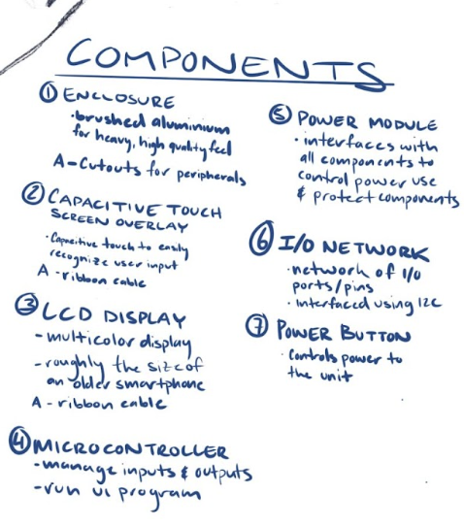

Drawing 1 Description: Concept for touch screen device that can have a user interface and controls configured on a companion software than used as a UI for a given system (in this case a light bulb)

## **2.2 ProtoKit**

## 

Description: Concept for a User interface kit that ships with a central panel and a choice of side panels that can be magnetically attached to the panel.

## **2.3 Modular (location dependent)**

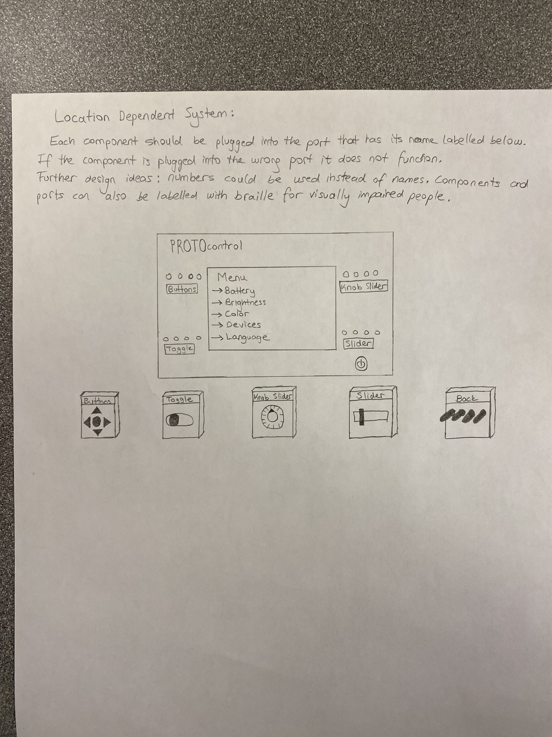

Description: In the location dependent system, the components (buttons and sliders that control the user interface) should be plugged into the main panel at the specified location using I2C. Failure to connect the device to the correct port will result in the component not functioning since the function of the component is dependent on the location of the port.

The measurements of the device is about 5 by 3 inches.

## **2.4 Modular (component dependent)**

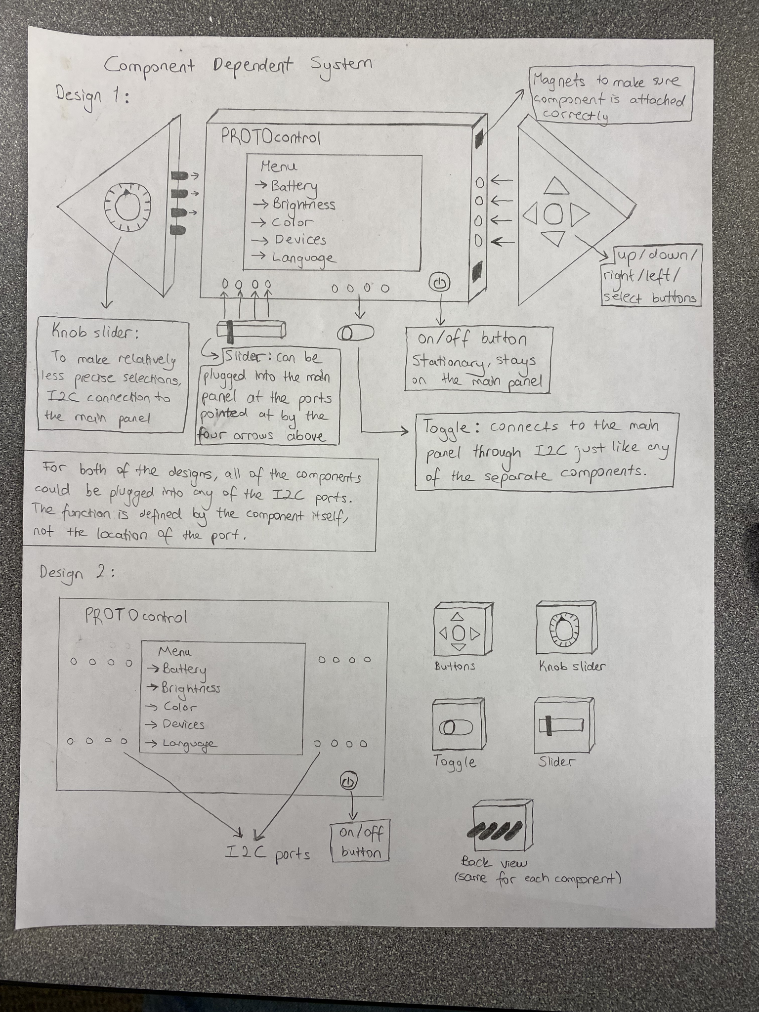

Description: The components (the parts the user is interacting with except for the on/off button) are separate from the main panel of the device which is the LCD displaying the user interface. In this type of system, all of the components can be attached to the main panel at the I2C ports and will be functional regardless of the location it is plugged into on the panel. The functions of the component is defined by the component itself and is not dependent on the port location.

The measurements of the device is about 5 by 3 inches.

## **2.5a Mobile Device as Touch Screen**

## **2.5b Mobile Device as Touch Screen (zoomed in)**

## 

Drawing 5 Description**:** This iteration of the design uses a smartphone app as the display and the platform to design the display. When the user customizes the display, they can select what pin on the user MCU connects to the UI toggle on the mobile app. The hardware IC has a bluetooth module and an

## 

## **2.6 Software UI**

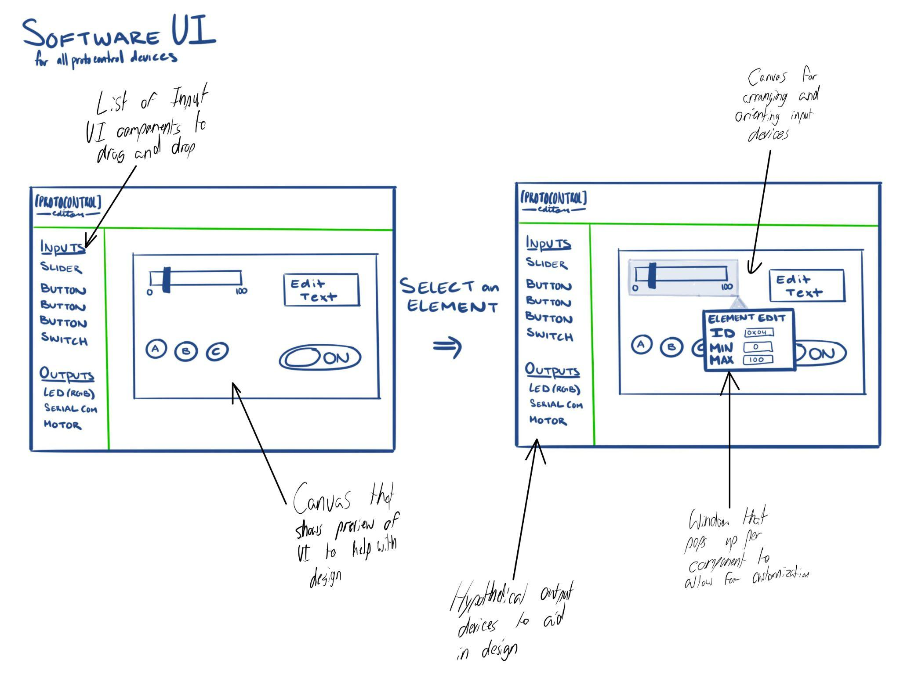

* *Include a brief explanation of the features in words for each diagram.*
* *Name each of the concepts with a name that captures the essence of the concept and number each concept. Use this name throughout this document to make it easier to track the concepts.*

## **Concept differences table and mockup demo preparation:**

*Include a table discussing the differences and similarities between all the concept diagrams. Your concept design ideas might differ based on what high-level technology you think you will use for the project. Think of the feasibility of making what you draw. What material can be used to build it? Is it going to be easy to assemble and test? If you make it, will it be easy to remake if things break? Is it a modular design? Think of manufacturability, maintainability, and durability when you draw something/anything.*

*E.g. one antenna design vs. multiple antennae designs*

*Wireless vs. wired connections*

*Table mount vs. wall mount*

*Hardware vs. software solution*

*Drag and drop vs. checkboxes*

You will make a complete mockup of at least one of your concepts by (Preliminary Design Review week). Think of how each concept mockup can be made and add that at the end of row.

|  | 1. ProtoPad | 2. ProtoKit | 3. Modular (location dependant) | 4. Modular (component dependant) | 5. Mobile device and app as system UI | 6. Software UI |
| --- | --- | --- | --- | --- | --- | --- |
| Inputs | Touchscreen | Swappable inputs | From various serial ports | Array of serial ports (i2c) | Website inputs, keyboard, mouse, and uploaded image | Website inputs, keyboard, mouse, and uploaded image |
| Modularity | module | module | Semi modular | Very modular | NA | NA |
| Ease of setup | Very easy, no additional components required | Easy, but need to choose inputs | Challenge of identifying ports | Utilize i2c port array | Lots of software backet dev work | Algorithm work |
| Difficulty of software development | IS REALLY FUN AND KINDA CHALLENGING BUT DO-ABLE | IS LESS CHALLENGING AND MORE MONOTONOUS | TBD | Embedded code to work with all components | Challenging UI work | Algorithm work |
| Making of the concept Mockup | More work initially to set up display | Easier to breadboard out | Design port system, TBD | Relatively straightforward | Non functional frontend doable | Website demo |

Table 1: Concept differences

Quick prototype of selected system to be prioritized

# **User operational Flowcharts/process diagrams *(20 points)***

*Think of how the user will operate the system. From setting up, all the actions performed by the user and appropriate system responses back to the user. What modes/options/ features will the user have?* ***You may have one high-level user operation diagram and variations to go with your concept ideas.***

* *Please include flowcharts, process- diagrams, or pictorial explanations of each mode/action.*
* *Think of high-level user operations and not complex system-level component-level operations.*
* *If relevant, you can include some high-level system operations related to system response to the user. E.g., the product will calculate the distance in meters and store*
* *Think of the suitable units (temp in F, distance in meters, humidity in %, etc.)*
* *Think of all the modes the system can be*
* *Think of system status feedback to the user.*

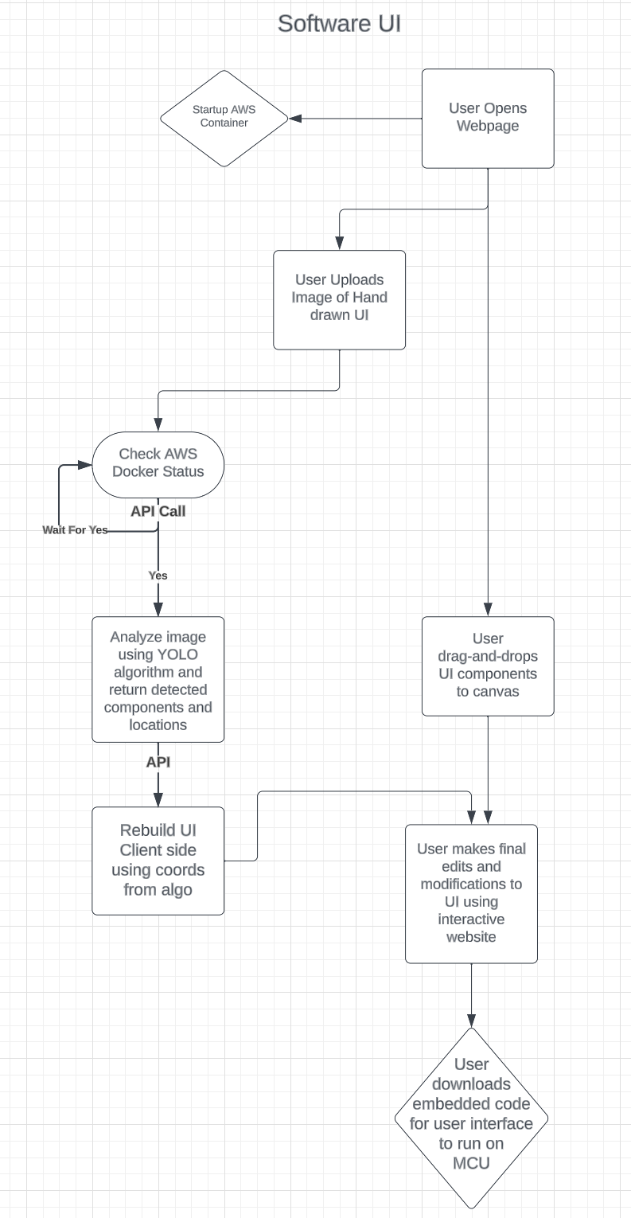

# **System Functional Block Diagram *(25 points)***

*This is from the engineering perspective. Think of various high-level blocks your system will have, e.g., power unit, processor, sensors, actuators, mechanical accessories, communication units, user applications, GUI.*

* *User blocks and connecting links/arrows*
* *Each block should have a name and corresponding functions it will perform*
* *Each arrow/link should have input and output data stated (with units if applicable)*
* *Use color codes if necessary to talk about the different categories of blocks, e.g., external to the system, internal to the system, hardware blocks, software blocks*
* *If your system is part of a bigger system then that should be shown in your block diagram and mark a way to decide what is your system and what is given to you or the external system.*
* ***If you have multiple block diagrams relating to various product concept ideas, then include multiple. Include a table to state the differences.***
* *Include a* ***brief*** *explanation of each block and its functions.*

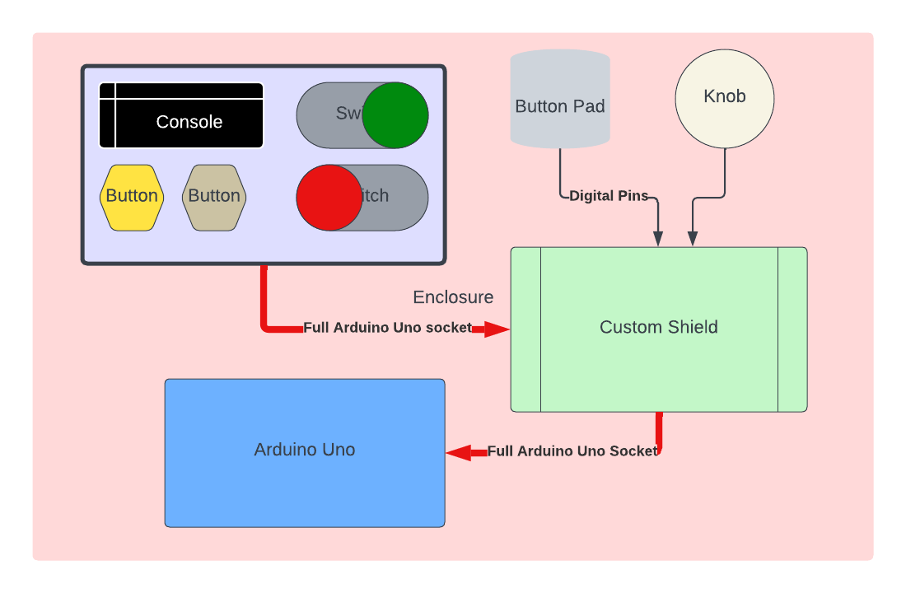

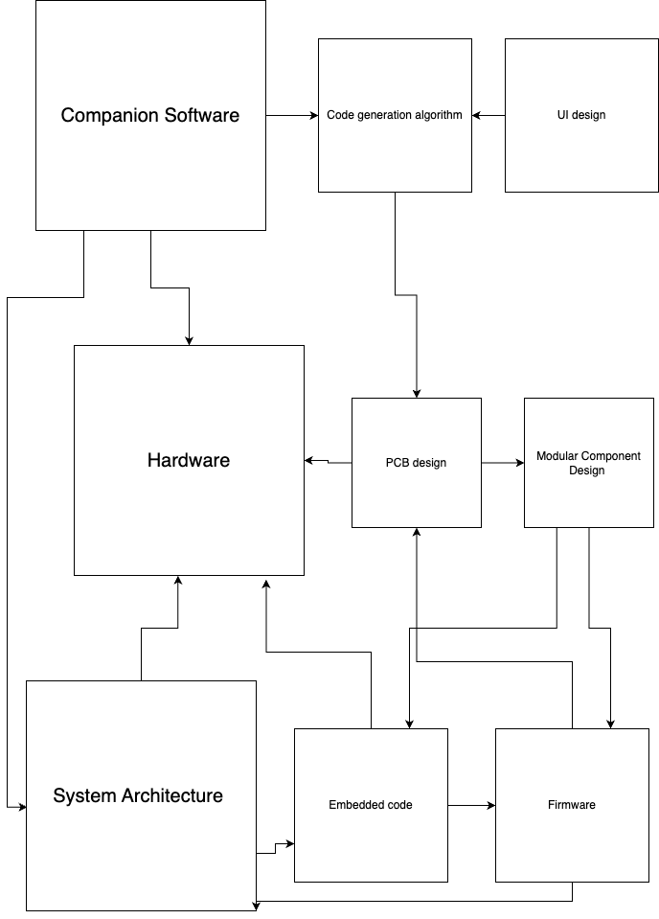

# **Table of Trade-offs (10 points)**

* *Use different colors and bullet points in each column and row to differentiate the pros and cons of each idea, related user operational difference if any, related functional block difference if any.*

| Key Requirements/Criteria | ProtoPad | ProtoKit | Location Based | Component-Based | Software |
| --- | --- | --- | --- | --- | --- |
| *Feasibility* | Somewhat feasible  Pro: Touchscreen can be easily interfaced with Arduino Touch shield  Con: Code must be transferred from web app to touchscreen | Feasible  Con: work on enabling various input devices | Con: Need to figure out how to identify locations | Pro: Very feasible using i2c | Con: Somewhat feasible, lots of work |
| *Compatibility* | Pro: Compatible with Arduino form factors and other microcontroller with adapter | Pro: Compatible with any i2c device  Con: | Con: Not as compatible with different layout options, as ports are specific | Pro: Quite compatible, works with every i2c device | Pro: Compatible with any website browser |
| *Ease of use* | Somewhat easy, digital inputs | Pro: Very easy, physical buttons and knobs | Con: Not as easy to use, as ports need to be labeled and remembered | Somewhat easy to use, allows functionality to be tied to components and port location is irrelevant | Pro: Somewhat easy to use  Con: detailed steps are required to instruct thought the process |
| *Ease of making* | Con: need to tune software and touch regions | Pro: Simple process, combine all inputs on network | Design a port identification process | Pro: Simple process, utilize parallel to serial GPIO expander | Con: Lots of testing and UI work |
| *Originality* | Pro: Quite original, with the ability to draw out component locations | Con: Somewhat original, utilized existing serial network Pro: allows for much easier design and customization | Pro: Somewhat original, custom port id process | Con: Somewhat original, uses existing serial network  Pro: allows for modularity | Pro: Very original, Allows for drawn UI |
| *cost* | Medium, capacitive touchscreen alone is $44 | Pro: Low, LCD and Small components under 20 | Pro: Slightly higher than component-based | Pro: Lower cost | Con: High maintenance cost |
| *Overall Evaluation* | Pro: An applicable process for designing a touchscreen user interface. With a huge array of custom input controllers, this process fits almost every application it is suited for | Pro: A simpler, lower cost process for smaller and more focused UI applications. Unbeatable modularity, excellent for user trials | Pro: This process allows for more rapid testing of a single component layout | Pro: This process is incredibly flexible and allows for on the go swapping | Pro: The Software generation is a key breakthrough in removing technical skill from UI design |

# **Design challenges**

* *Universality - Integration with multiple user MCUs*
  + *It will be challenging to integrate the Protocontrol device with the users system and microcontroller (we will be designing with 4 main microcontroller families in mind: ESP, MSP430, R-PI, Arduino). There are several key differences in the major microcontrollers including:*
    - *Power/current ratings*
    - *Operating systems (Raspberry PI uses its own OS)*
    - *Variation in pin locations*
    - *Different processing power*
    - *Presence of wireless connection modules (Arduino has components that can be added on whereas Raspberry Pi can connect to the internet by default)*
* *Automatic code generation (applicable for the touch screen iteration of the project)*
  + *After the user sets up the display and selects which pin on their system connects to each UI component on the display, the appropriate code needs to be generated by the web app so that the user can download it into the MCU provided by Protocontrol.*
* *Modularity - Interfacing with multiple modular components at the same time (applicable for the*

*Hardware Demo iteration of the project)*

* + *System must allow for swappable components (button, switch, toggle) to be attached to main panel pins. For example a user may decide to use a switch instead of a button to control their LED. The system must recognize when UI components are exchanged and detect a change in component function. Outputs must go into a hold state if device is not detected. In the long term, concept drawings 3 and 4 must be combined to create a system that is neither pin location or component dependent. While this gives the user flexibility it means we must account for more variations.*
  + *Components may have different power requirements*
* *Magnets on enclosure may interfere with electronics*
  + *While implementation of a magnetic enclosure is straightforward, resulting issues with electromagnetic interference may be difficult to troubleshoot.*
* *Producing custom ICs*
  + *After the initial design and synthesis phase, designing packaging, and fabricating custom ICs may be a time consuming process.*
  + *In order to create a custom IC, a top level pin diagram is necessary. We must understand what outputs each variation of the system will require of the IC. We must decide on the pins and layout of the pins while many other aspects of the system are still in flux.*

# **First technical milestone Preparation (“Hello World” demos)**

The first technical milestone will be what the team presents during the ECE Hall of Fame Event. The milestones have been decided with this event in mind.

Table 3

| **Identified Technology/Tool** | **Project purpose** | **Specific ways of getting up to speed/help needed** | **“Hello World” demo** |
| --- | --- | --- | --- |
| *Python + Multiple Object Detection Algorithm* | *Project will include a Machine Learning Algorithm for identifying hand drawn i/o components (sliders, toggles, buttons, arrow buttons, textbox, terminal watch window) .* | *Online documentation, Reference previous projects, reach out to experts* | *Train the existing model on hand drawn images created by team members*  *Software Demo*  *Test the trained algorithm with a drawing of UI components on a napkin* |
| *Fusion 360 + ECE MakerSpaces* | *Project will require a 3D printed enclosure (eventually metal) with magnetic snaps (resembling Apple’s mag-safe charger port)*  *Project will benefit from a rendered video of the final product* | *Fusion 360 Tutorials and youtube videos.*  *Mr. Nugyen has documentation for the 3D printing process in EB2.*  *NCSU’s library also offers technology consultations if the problem cannot be resolved earlier.* | *The demo will be 3D printed enclosures (triangle shape shown in earlier drawings) for 3-4 components that connect to a central panel including an LCD display and LED. The enclosure will be made of PLA or ABS plastic.*  *The enclosure will include a place to embed small craft magnets.* |
| *Embedded code for various input components* | *Embedded code is needed for MCU to communicate with any selected component.* | *Adafruit/sparkfun tutorials and example code, online code* | *Hardware Demo*  *The central panel will have and LED and LCD display. There will be 2 ports on the central panel that can accept two main categories of UI component:*  *1) components that can turn on/off the LED*  *2) components that can modify the brightness of the LED.*    *The user will be able to replace a button with a toggle and a slider with a rotary encoder. The system will be able to detect when no input is present and also smoothly transition as the user switches out components.* |

# **Long-lead-time or critical items for purchasing**

Table 4: Items to purchase

(table is linked to “Hardware Inventory and spec sheets” in the “Hardware Files” folder; DO NOT edit here)

| **Item:** | **Description:** | **Cost:** | **Quantity:** | **Vendor:** | **Justification:** |
| --- | --- | --- | --- | --- | --- |
| UNO OLED shield | 2.8" TFT Touch Shield for Arduino with Capacitive Touch | $44.00 | 1.00 | Adafruit | UI component necessary for 1st Demo (Hardware section). I2C protocol compliant. We are planning on creating an enclosure for each component and connecting it to the main panel with an LCD display. |
| I2C Slider | Adafruit NeoSlider I2C QT Slide Potentiometer with 4 NeoPixels - STEMMA QT / Qwiic | $9.95 | 1.00 | Adafruit (5295) | UI component necessary for 1st Demo (Hardware section). I2C protocol compliant. We are planning on creating an enclosure for each component and connecting it to the main panel with an LCD display. |
| I2C Joystick | SparkFun Qwiic Joystick | $11.50 | 1.00 | Sparkfun (com-15168) | UI component necessary for 1st Demo (Hardware section). I2C protocol compliant. We are planning on creating an enclosure for each component and connecting it to the main panel with an LCD display. |
| I2C Button Pad | SparkFun Qwiic Keypad - 12 Button | $11.50 | 1.00 | Sparkfun (com-15290) | UI component necessary for 1st Demo (Hardware section). I2C protocol compliant. We are planning on creating an enclosure for each component and connecting it to the main panel with an LCD display. |
| I2C Rotary Encoder | SparkFun Qwiic Twist - RGB Rotary Encoder Breakout | $24.95 | 1.00 | Sparkfun (dev-15083) | UI component necessary for 1st Demo (Hardware section). I2C protocol compliant. We are planning on creating an enclosure for each component and connecting it to the main panel with an LCD display. |